Laporan Test Automation Login

Tanggal Run: 2026-01-14

Target URL: http://localhost:51201

Screenshots Folder: test_reports\screenshots_20260114_172310

--------------------------------------------------

**Scenario: 1. Login Sukses (Valid/Valid)**

Input: User='admin' | Pass='admin123'

Expect: Success | Actual: Success

**Status: Passed**

Step 1: Empty Form

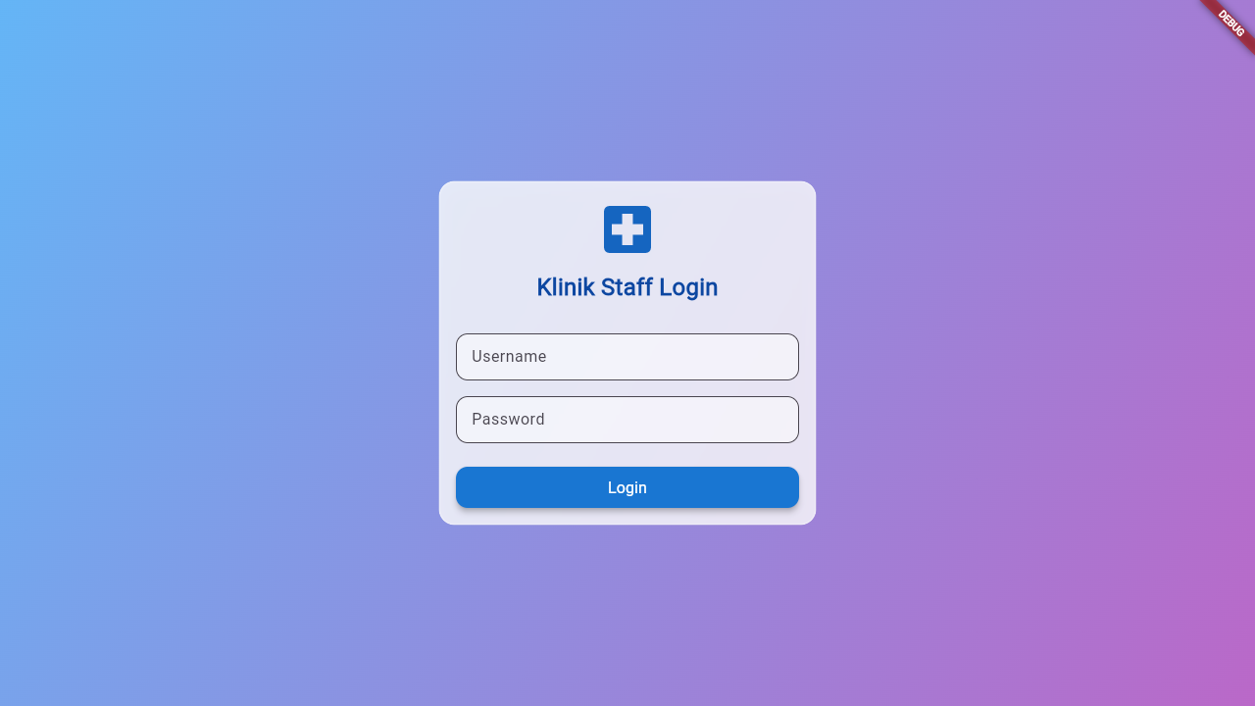

Step 2: Filled Inputs

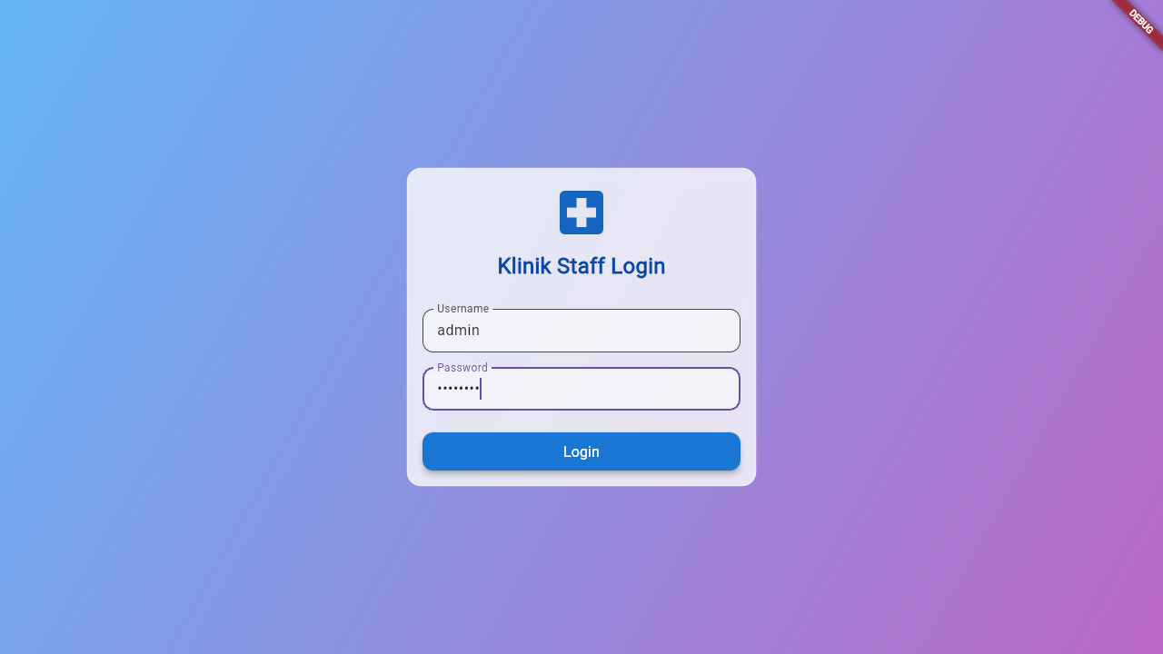

Step 3: Result

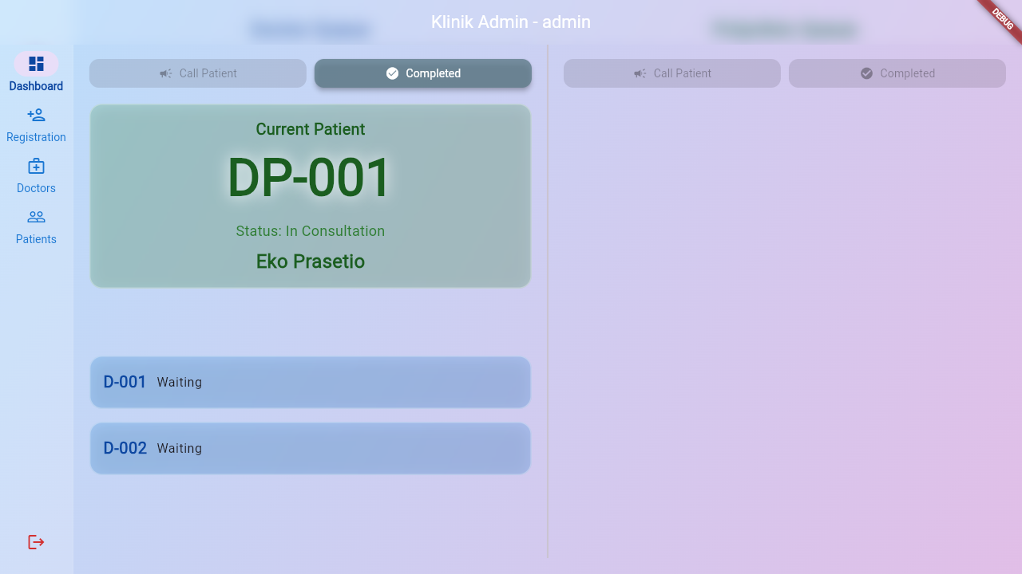

------------------------------

**Scenario: 2. Login Gagal (Invalid/Invalid)**

Input: User='wronguser' | Pass='wrongpass'

Expect: Fail | Actual: Fail

**Status: Passed**

Step 1: Empty Form



Step 2: Filled Inputs

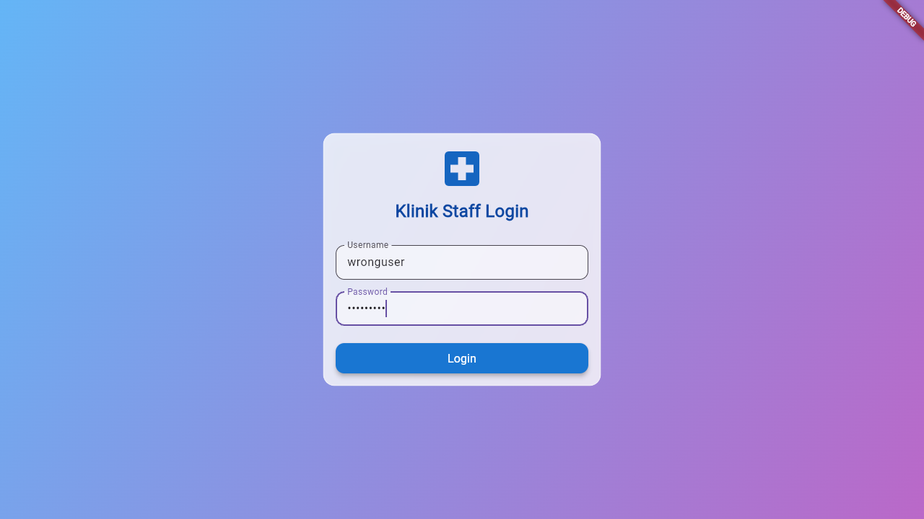

Step 3: Result

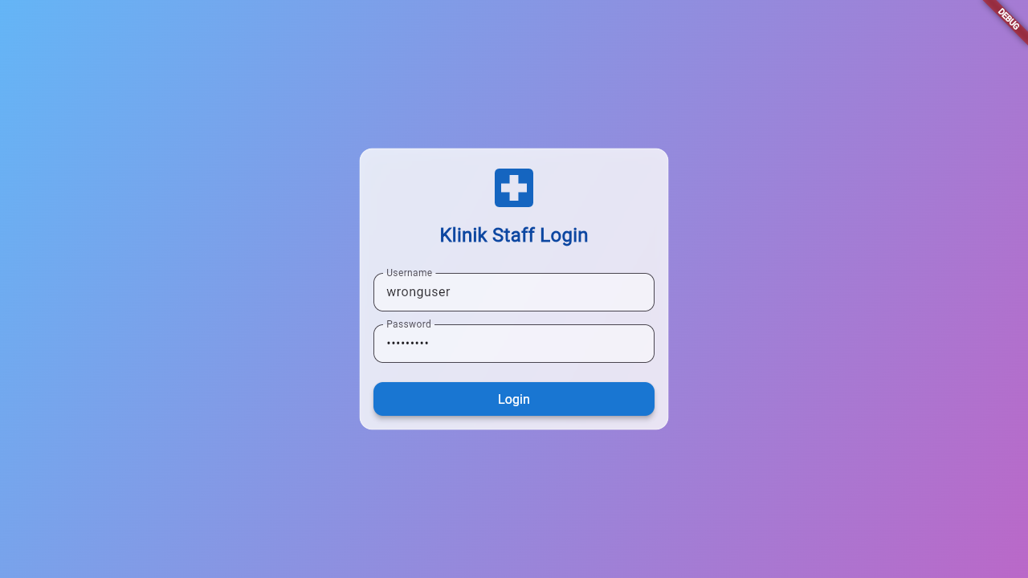

------------------------------

**Scenario: 3. Login Gagal (Valid/Invalid)**

Input: User='admin' | Pass='wrongpass'

Expect: Fail | Actual: Fail

**Status: Passed**

Step 1: Empty Form



Step 2: Filled Inputs

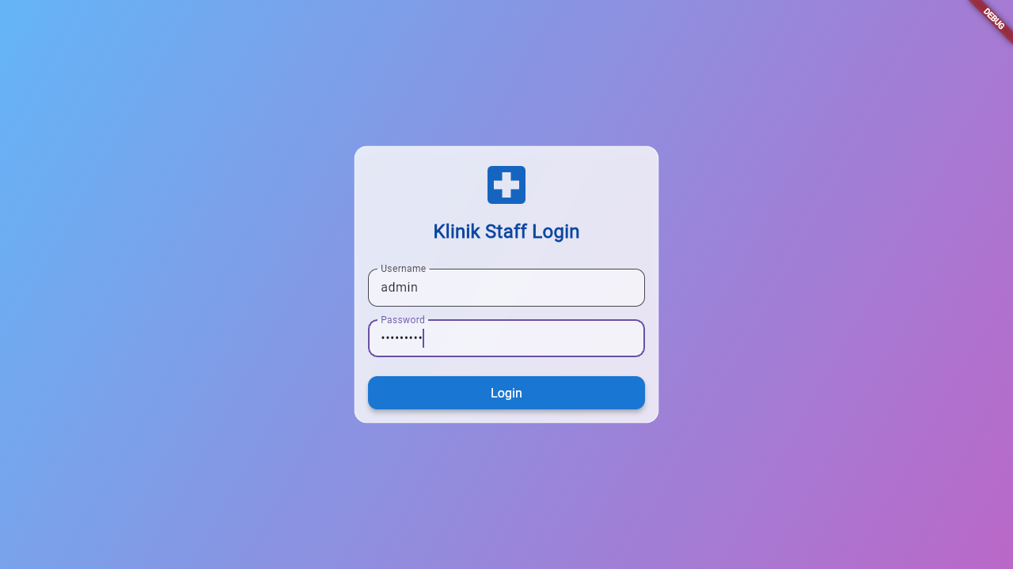

Step 3: Result

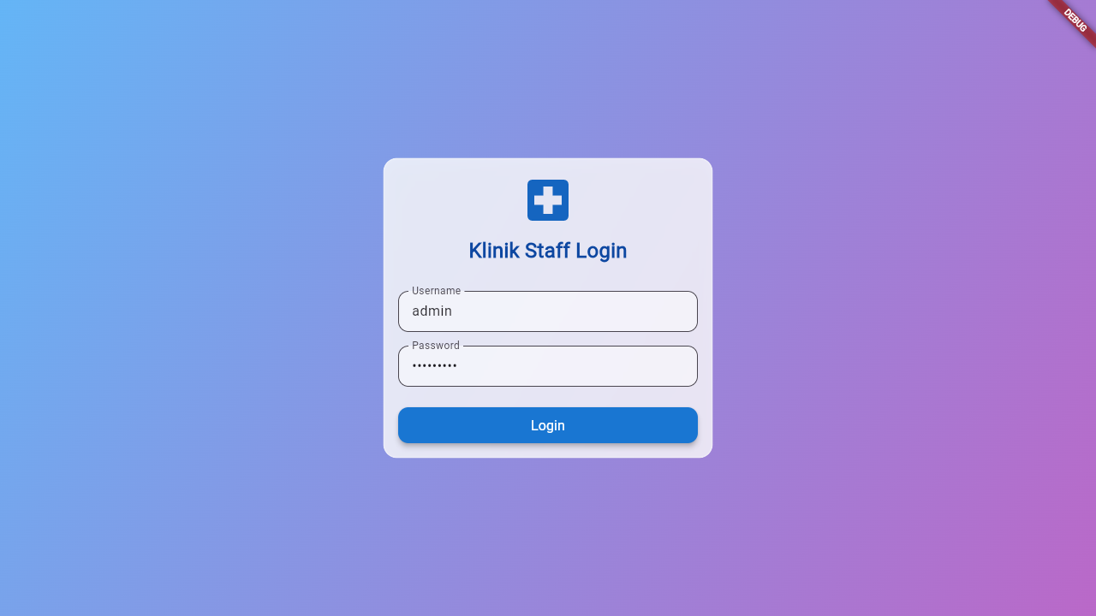

------------------------------

**Scenario: 4. Login Gagal (Invalid/Valid)**

Input: User='wronguser' | Pass='admin123'

Expect: Fail | Actual: Fail

**Status: Passed**

Step 1: Empty Form



Step 2: Filled Inputs

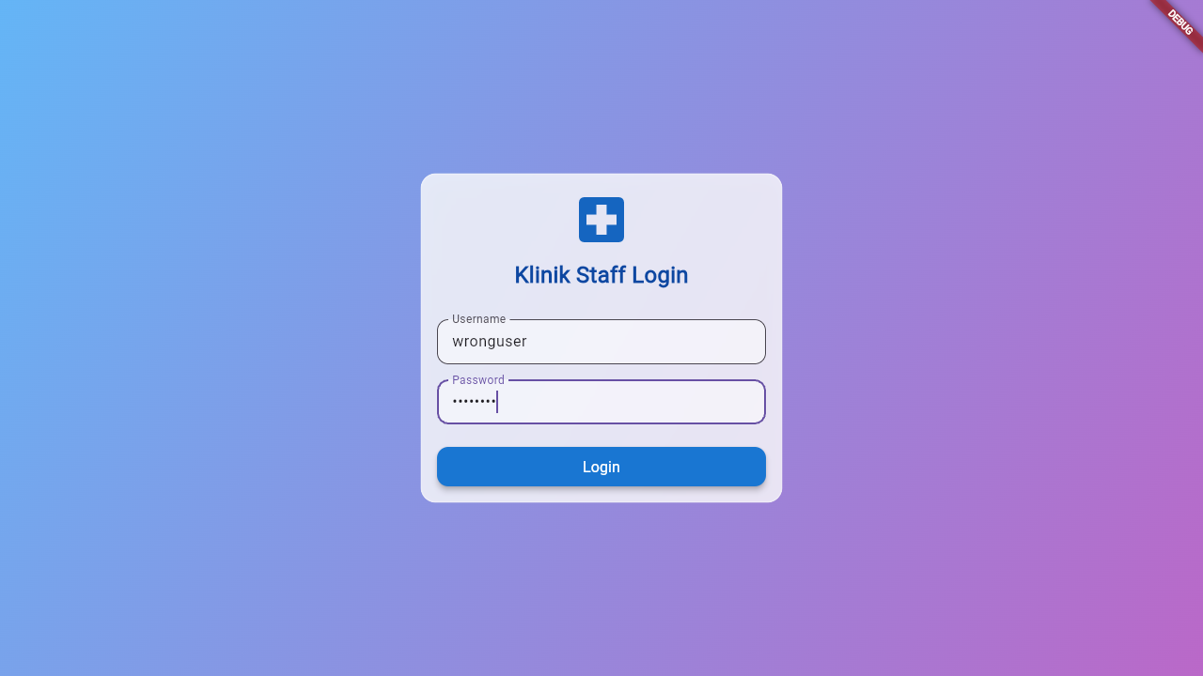

Step 3: Result

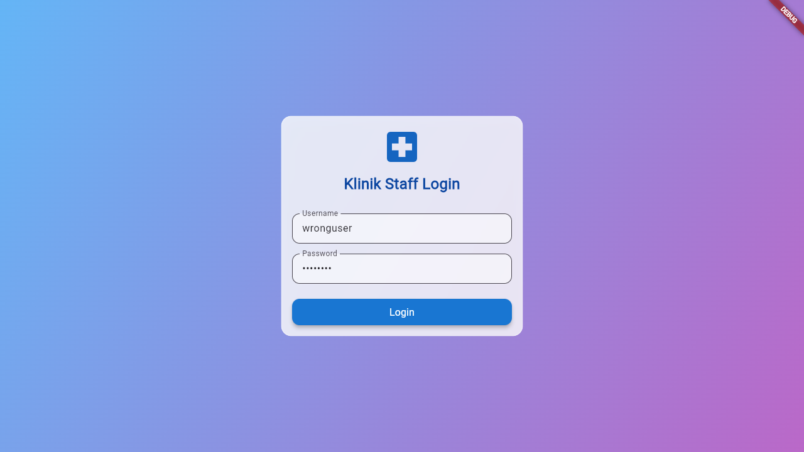

------------------------------

**Scenario: 5. Login Gagal (Empty/Empty)**

Input: User='' | Pass=''

Expect: Fail | Actual: Fail

**Status: Passed**

Step 1: Empty Form



Step 2: Filled Inputs

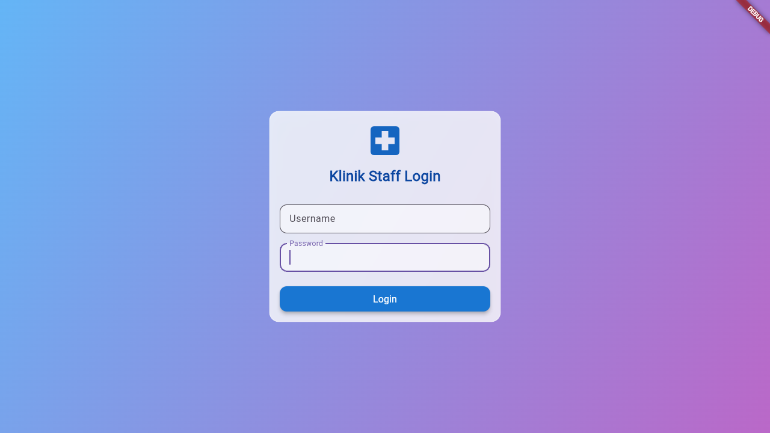

Step 3: Result



------------------------------

**Scenario: 6. Login Gagal (Valid/Empty)**

Input: User='admin' | Pass=''

Expect: Fail | Actual: Fail

**Status: Passed**

Step 1: Empty Form



Step 2: Filled Inputs

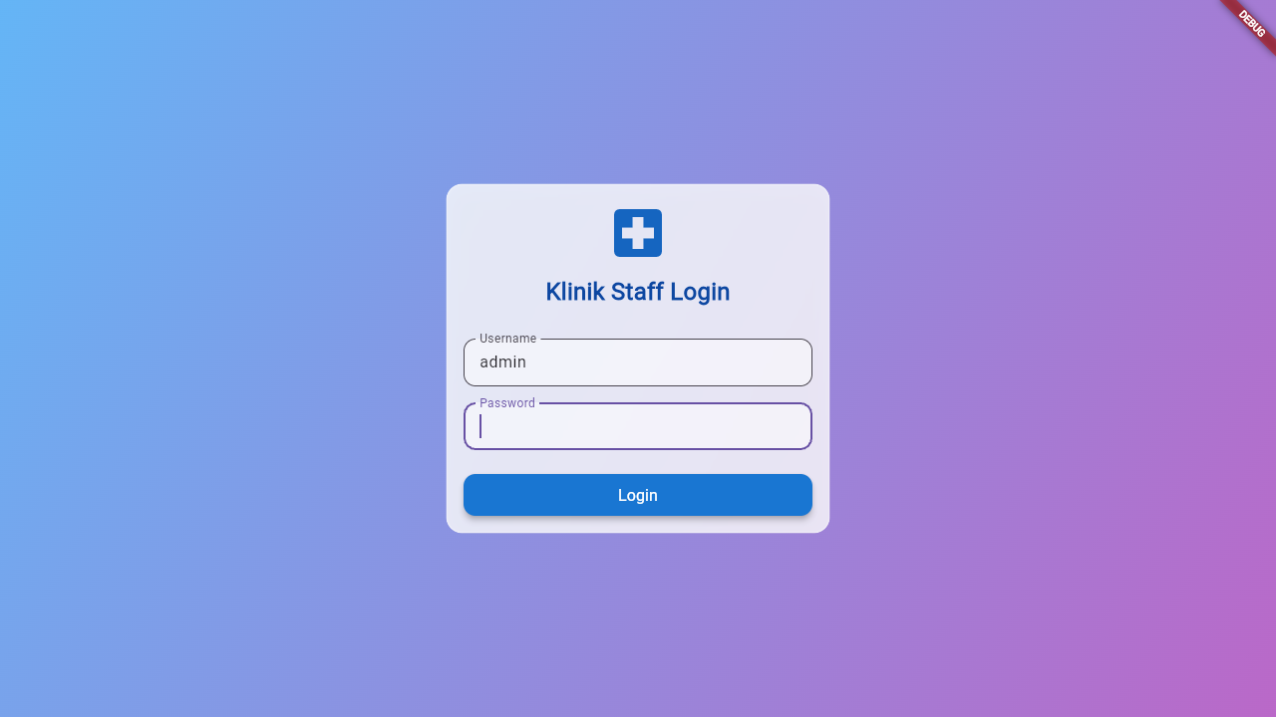

Step 3: Result

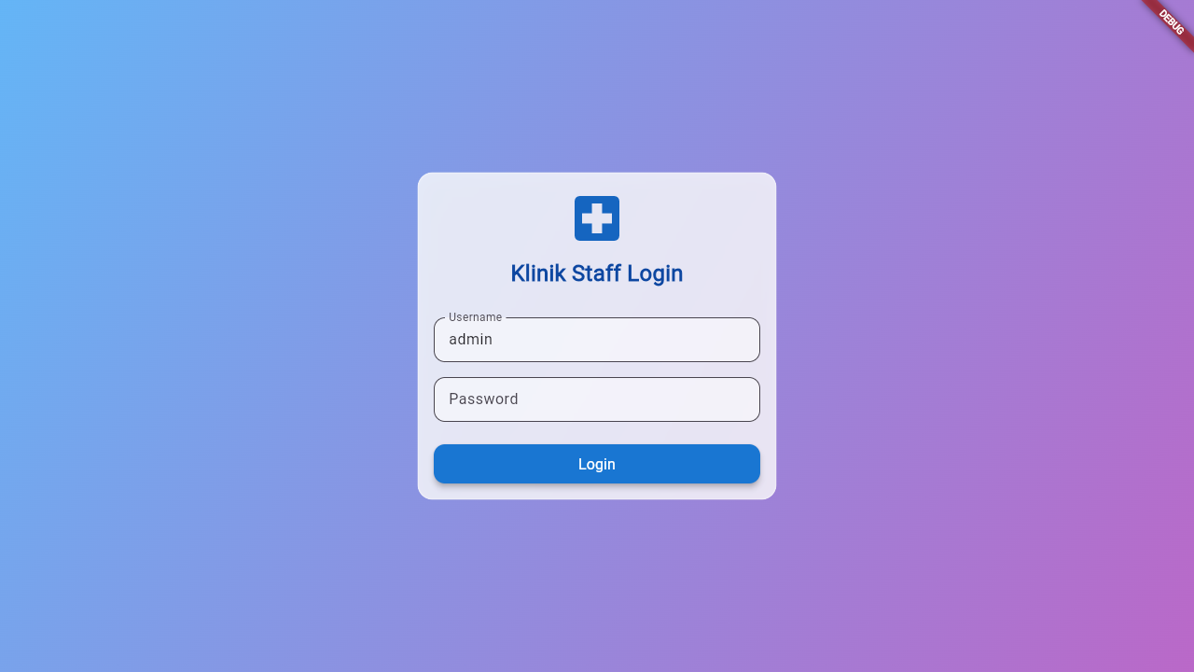

------------------------------

**Scenario: 7. Login Gagal (Invalid/Empty)**

Input: User='wronguser' | Pass=''

Expect: Fail | Actual: Fail

**Status: Passed**

Step 1: Empty Form



Step 2: Filled Inputs

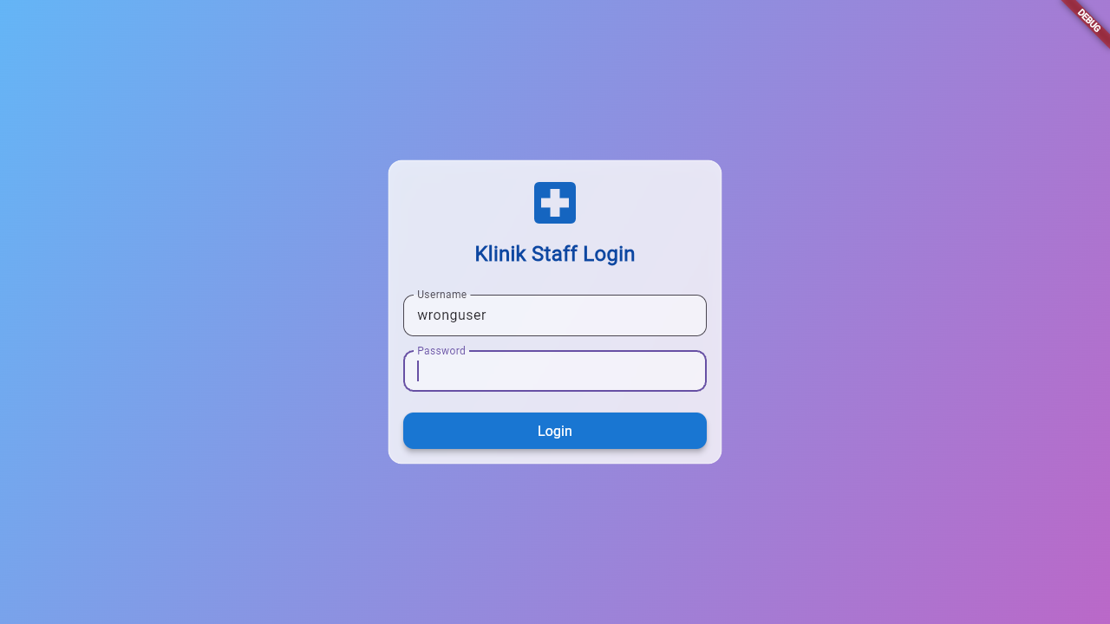

Step 3: Result

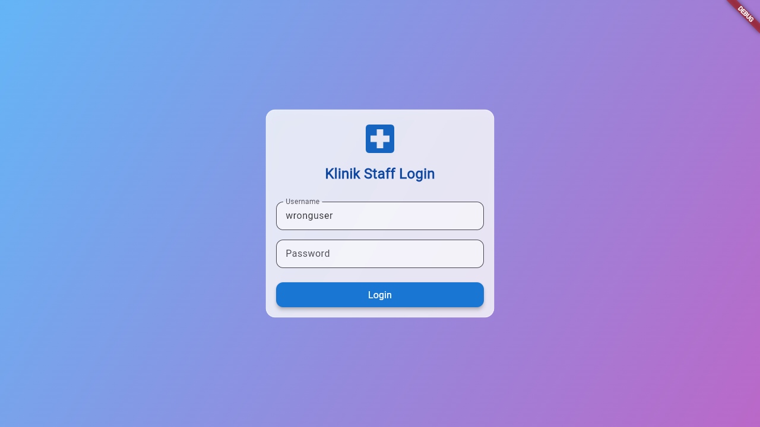

------------------------------

**Scenario: 8. Login Gagal (Empty/Valid)**

Input: User='' | Pass='admin123'

Expect: Fail | Actual: Fail

**Status: Passed**

Step 1: Empty Form



Step 2: Filled Inputs

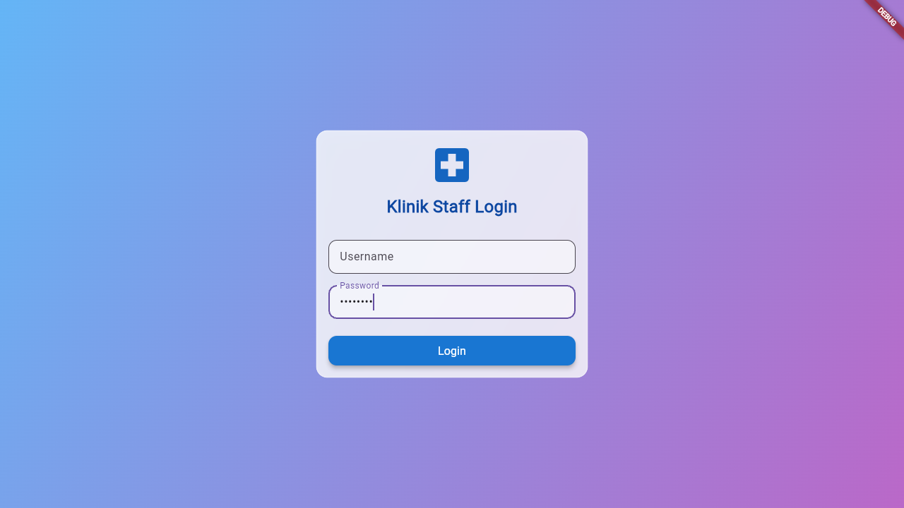

Step 3: Result

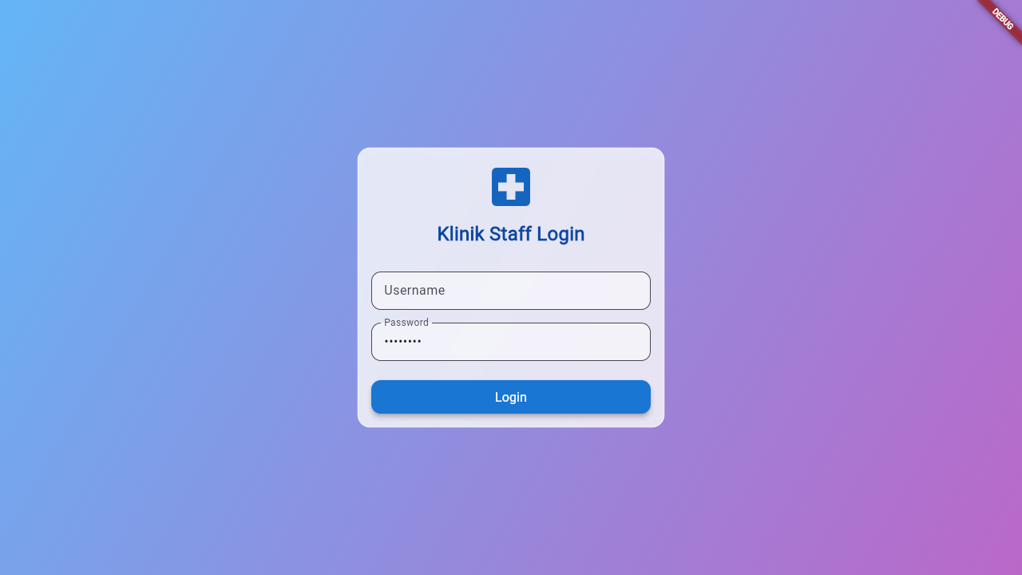

------------------------------

**Scenario: 9. Login Gagal (Empty/Invalid)**

Input: User='' | Pass='wrongpass'

Expect: Fail | Actual: Fail

**Status: Passed**

Step 1: Empty Form



Step 2: Filled Inputs

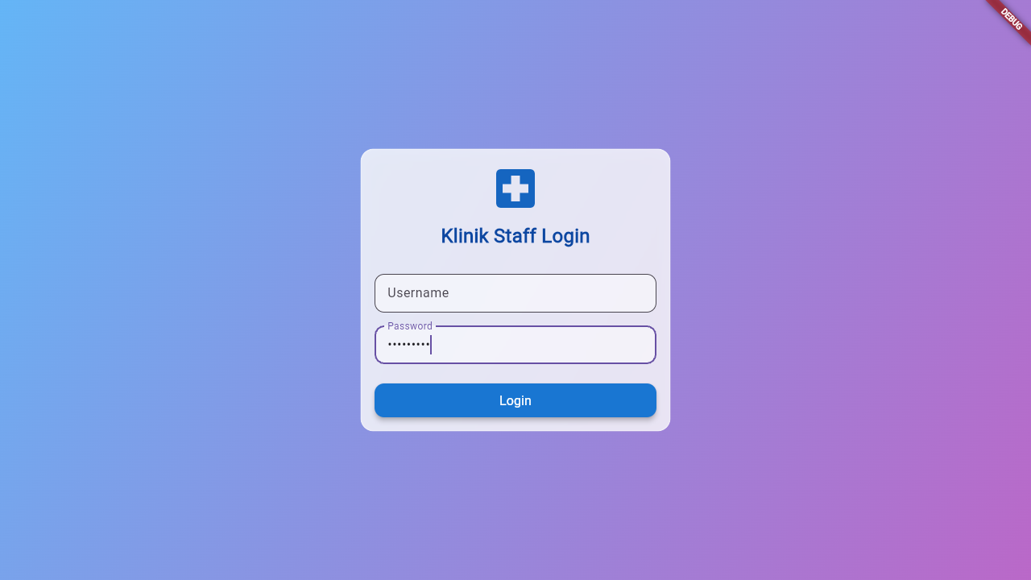

Step 3: Result



